**Progress report 16**

Tawab Karim

|  |  |
| --- | --- |
| Date | 28/01/2019 |
| Subject | AIM |
| Project Term |  |

# Outcomes of the last meeting (17/12/2019)

* Organize the visit for the students of KU Leuven. Do this in collaboration with Elizabeth, Daan and Nynke.
* Model 3D-Tilt optical system in zemax and see if it compares to reported results.
* Select optical components for light sheet module
* AIM lightsheet should be a simpler design then the design used in 3D-Tilt paper

# Results during the last week(s)

* 3D-Tilt setup is also diffraction limited, matches with reported results (Appendix A)
* Optical components defined using zemax thanks to Gleb (Appendix B)
* One custom lens needed, this can maybe be produced with Bart Snijders
* Rough planning made for KU Leuven students (Appendix C)

# Other business

* I will be in Iceland next week

# Plans for next week(s)

* Make list of to-do’s for content on the website
* Start with mechanical design around the optical components for the light sheet
* Help Jaap with the alignment of the DMD
* Finalize the planning for the KU Leuven students

# Schedule current and next week

## This week

* Tuesday 0900-1700
* Thursday 0900-1700

## Next Week

* -

# Appendix A

# 

Figure 1: Spot diagram at focus point for 3D-Tilt with Airy disk

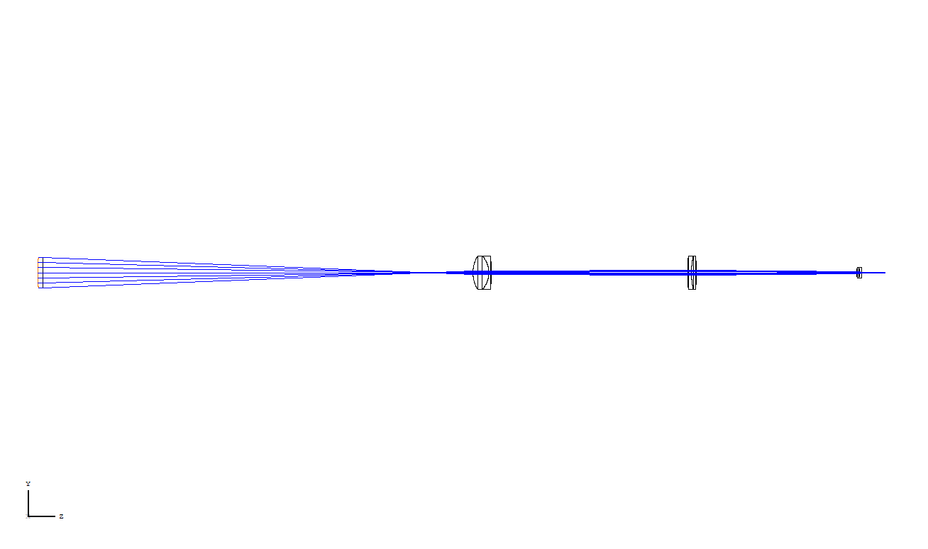

Figure 2: Rendered model of 3D-Tilt Light sheet

# Appendix B

# 

Figure 3: Spot diagram new optical design

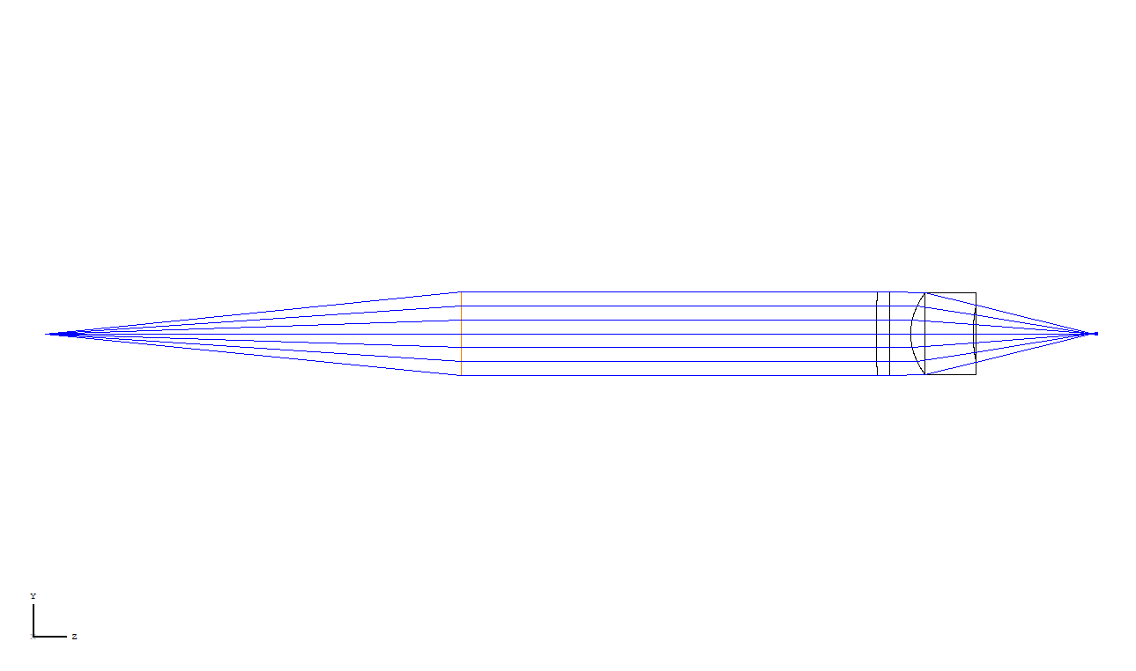

Figure 4: Rendered model of new optical design

# Appendix C

7th of February from 10:00 till 12:30

Labs that will be visited;

Smith Lab

Zebrafish NeuroDev Lab

Brinks Lab

Talks given by;

Gleb Vdovin

Belen Solano Hermosilla (Bionanoscience)

Hall G has been reserved.

Details are currently being determined.

|  |  |  |  |  |
| --- | --- | --- | --- | --- |
| Project | Figure | Current Components | Needed Components | Earliest Due Date |
| DMD-Setup | LINK |  |  |  |
| TIRF-Setup | LINK | 1,2,3,4,6,7,8,10 | 5,9 | 30/09/2019 |
| LS-Module | LINK |  |  |  |

## 

|  |  |  |  |  |  |
| --- | --- | --- | --- | --- | --- |
| Figure no. | Component code | Component Name | Amount in Inventory | Amount in production | Production due date |
| 1 | CR001-A | Microscope Tower | 1 | 2 | 30/09/2019 |
| 2 | CR002-A | EM Plate | 1 | 2 | 30/09/2019 |
| 3 | CR003-A | FilterPlate | 1 | 2 | 30/09/2019 |
| 4 | CR004-A | CoverPlate V2 P1 | 1 | 2 | 30/09/2019 |
| 5 | CR005-A | CoverPlate V2 P2 | 0 | 3 | 30/09/2019 |
| 6 | CR006-A | BottomPlate | 1 | 2 | 30/09/2019 |
| 7 | CR007-A | Stage Mount | 3 | 0 | - |
| 8 | CR008-A | Stage Plate | 3 | 0 | - |
| 9 | CR009-A | Tube Lens Mount | 0 | 1 | 18/10/2019 |
| 10 | PP001-A | CameraMount | 2 | 0 | - |
| 11 | CR008-B | Stage Plate | 0 | 1 | 18/10/2019 |
| 12 | CR010-A | StageThorlabsAdapter-A | 0 | 1 | 18/10/2019 |
| 13 | CR011-A | StageThorlabsAdapter-B | 0 | 1 | 18/10/2019 |
| 14 | CR012-A | SpacerBlockStage | 0 | 1 | 18/10/2019 |
| 15 | CR013-A | FilterPlateStraight | 0 | 1 | 18/10/2019 |
| 16 | CR020-A | PanelLaserBox1 | 0 | 1 | 04/10/2019 |
| 17 | CR021-A | PanelLaserBox2 | 0 | 1 | 04/10/2019 |
| 18 | CR022-A | PanelLaserBox3 | 0 | 1 | 04/10/2019 |
| 19 | CR023-A | PanelLaserBox4 | 0 | 1 | 04/10/2019 |
| 20 | CR024-A | PanelLaserBox5 | 0 | 1 | 04/10/2019 |
| 21 | CR025-A | PanelLaserBox6 | 0 | 1 | 04/10/2019 |
| 22 | CR026-A | PanelLaserBox7 | 0 | 1 | 04/10/2019 |
| 23 | CR027-A | PanelLaserBox8 | 0 | 1 | 04/10/2019 |
| 24 | CR028-A | PanelLaserBox9 | 0 | 1 | 04/10/2019 |
| 25 | CR029-A | PanelLaserBox1D | 0 | 1 | 04/10/2019 |
| 26 | CR030-A | PanelLaserBox4D | 0 | 1 | 04/10/2019 |
| 27 | CR014-A | OuterBlock1 | 0 | 1 | 31/01/2020 |
| 28 | CR015-A | OuterBlock2 | 0 | 1 | 31/01/2020 |
| 29 | CR016-A | InnerBlock | 0 | 1 | 31/01/2020 |
| 30 | CR017-A | PolerazationConnector | 0 | 1 | 31/01/2020 |
| 31 | CR018-A | PolerazationSelector | 0 | 1 | 31/01/2020 |
| 32 | CR031-A | BackPlateMirror | 0 | 0 | - |
| 33 | CR032-A | MirrorRotMount | 0 | 0 | - |
| 34 | CR033-A | HoldPlate | 0 | 0 | - |
| 35 | CR034-A | Mounting | 0 | 0 | - |
| 36 | CR035-A | SidePlateConnector | 0 | 0 | - |
| 37 | CR036-A | SidePlateB | 0 | 0 | - |
| 38 | CR037-A | SidePlates | 0 | 0 | - |
| 39 | CR038-A | NemaMount | 0 | 0 | - |
| 40 | CR039-A | HaltePlatte | 0 | 2 | 31/01/2020 |
| 41 | CR040-A | Anschraubplatte | 0 | 2 | 31/01/2020 |
| 42 | CR041-A | Kugelhalter2 | 0 | 4 | 31/01/2020 |
| 43 | CR042-A | Kugelhalter | 0 | 2 | 31/01/2020 |
| 44 | CR043-A | Kugelhalter3 | 0 | 2 | 31/01/2020 |
| 45 | CR044-A | BasePlateStage | 0 | 1 | 10/01/2020 |
| 46 | CR045-A | MountingPlate | 0 | 2 | 10/01/2019 |
| 47 | CR046-A | StepConnectPlate | 0 | 1 | 10/01/2019 |
| 48 | CR047-A | BackPlateMirror | 0 | 1 | 10/01/2019 |
| 49 | CR048-A | HoldPlate | 0 | 1 | 10/01/2019 |
| 50 | CR049-A | MirrorRotMount | 0 | 1 | 10/01/2019 |
| 51 | CR050-A | Mounting | 0 | 1 | 10/01/2019 |
| 52 |  |  |  |  |  |
| 53 |  |  |  |  |  |
| 54 |  |  |  |  |  |
| 55 |  |  |  |  |  |
|  |  |  |  |  |  |
|  |  |  |  |  |  |
|  |  |  |  |  |  |
|  |  |  |  |  |  |
|  |  |  |  |  |  |
|  |  |  |  |  |  |
|  |  |  |  |  |  |
|  |  |  |  |  |  |
|  |  |  |  |  |  |
|  |  |  |  |  |  |
|  |  |  |  |  |  |

## Project figures

|  |
| --- |
| DMD-Setup |
|  |
| TIRF-Setup |
|  |
| LS-module |
| -image not yet made- |

## Component figures

|  |  |
| --- | --- |
| Figure 1 -- CR001-A | Figure 2 – CR002-A |
|  |  |
| Figure 3 – CR003-A | Figure 4 – CR004-A |
|  |  |
| Figure 5 – CR005-A | Figure 6 – CR006-A |
|  |  |
| Figure 7 – CR007-A | Figure 8 – CR008-A |
|  |  |
| Figure 9 – CR009-A | Figure 10 – PP001-A |
|  |  |
| Figure 13 – CR008-B | Figure 12 – CR010-A |
|  |  |
| Figure 13 – CR011-A | Figure 14 – CR012-A |
|  |  |
| Figure 15 – CR013-A | Figure 16 – CR020-A |
|  |  |
| Figure 17 – CR021-A | Figure 18 – CR022-A |
|  |  |
| Figure 19 – CR023-A | Figure 20 – CR024-A |
|  |  |
| Figure 21 – CR025-A | Figure 22 – CR026-A |
|  |  |
| Figure 23 – CR027-A | Figure 24 – CR028-A |
|  |  |
| Figure 25 – CR029-A | Figure 26 – CR030-A |
|  |  |
| Figure 27 – CR014-A | Figure 28 – CR015-A |
|  |  |
| Figure 29 – CR016-A | Figure 30 – CR017-A |
|  |  |
| Figure 31 – CR018-A | Figure 32 – CR031-A |
|  |  |
| Figure 33 – CR032-A | Figure 34 – CR033-A |
|  |  |
| Figure 35 – CR034-A | Figure 36 – CR035-A |
|  |  |
| Figure 37 – CR036-A | Figure 38 – CR037-A |
|  |  |
| Figure 39 – CR038-A | Figure 40 – CR039-A |
|  |  |
| Figure 41 – CR040-A | Figure 42 – CR041-A |
|  |  |
| Figure 43 – CR042-A | Figure 44 – CR043-A |
|  |  |
|  |  |
|  |  |
|  |  |
|  |  |
|  |  |
|  |  |

# Appendix

### 

### 

### 

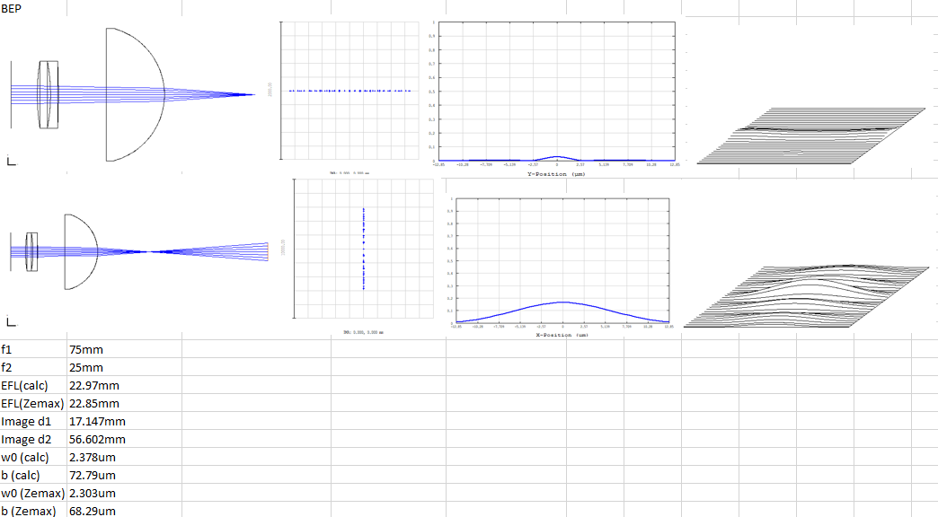

This is a summary of the simulations done with the components that the BEP group used. Looking at both focal distances of the light sheet. Hand calculations roughly match the simulations done in ZEMAX. The top row shows the first focal line of the light sheet and the second row shows the second focal line of the light sheet. From left to right, the setup, the dot diagram, the PSF cross section and the 3D PSF are shown.

This system has been compared to the inverted BEP setup, while the cilindrical lens is recommended to put the other way around. Results are shown below.

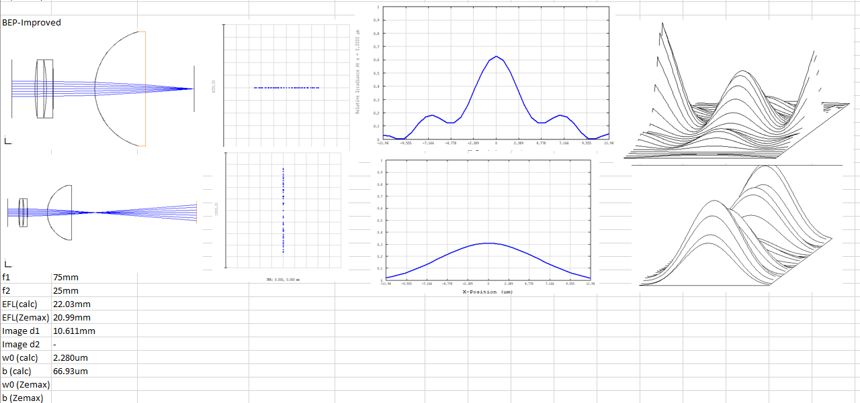

These two are compared to the AIM light sheet.

